**Iterator Pattern**

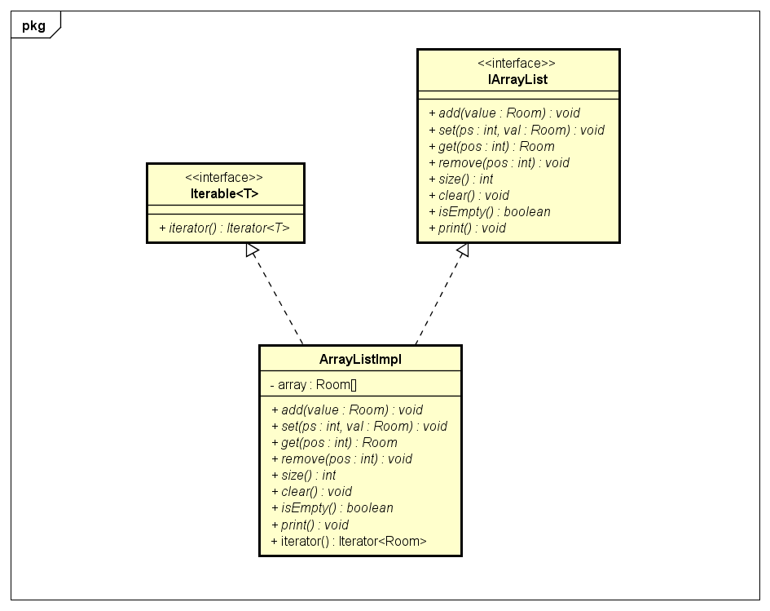

In our project we have created a collection called ArrayListImpl which implements the Iterable<T> interface. We have overridden the methods hasNext() and next(), so we can access the elements of a collection object in a sequential manner without any need to know its underlying representation.

